Learnlytica | Azure Databricks Practical Lab Workbook
CDC • CDF • Incremental Load • Auto Loader • Lakeflow SDP • DLT
Training level: Beginner to Intermediate Platform: Azure Databricks with Unity Catalog Business domain: Retail and E-Commerce Language: PySpark + Spark SQL
This workbook uses one common retail business scenario to demonstrate six essential data engineering techniques. Each exercise includes its definition, when to use it, why it matters, step-by-step code with comments, expected output, validation and real-world applications.

Lab overview
Lab | Topic | Real-world business requirement | Time
1 | CDC with MERGE | Synchronize changed customer orders | 15–20 min
2 | Delta CDF | Track updated and deleted orders | 15 min
3 | Incremental Load | Load only new transactions | 15 min
4 | Auto Loader | Automatically ingest arriving CSV files | 20–25 min
5 | Lakeflow SDP | Create a managed Bronze–Silver–Gold pipeline | 20–25 min
6 | DLT and Expectations | Implement declarative data quality controls | 15–20 min

Common real-time business scenario
Learnlytica Retail is an online shopping company processing thousands of customer orders every day.
Its operational database stores order information. New orders are placed continuously, customers modify existing orders, some orders are cancelled, and order data is delivered to Azure Data Lake Storage in multiple CSV files.
The engineering team must solve six problems:
- Synchronize changed orders into Delta tables.
- Capture changes for downstream applications.
- Avoid processing unchanged historical data repeatedly.
- Ingest newly arriving source files.
- Automate transformations through Lakeflow pipelines.
- Reject invalid business records and monitor data quality.

Common orders dataset
order_id | customer_id | amount | status | updated_at
101 | C01 | 1000 | PENDING | 2026-10-16 09:00
102 | C02 | 2000 | COMPLETED | 2026-10-16 09:05
103 | C03 | 1500 | PENDING | 2026-10-16 09:10
104 | C04 | 3000 | COMPLETED | 2026-10-16 09:15
105 | C05 | 500 | PENDING | 2026-10-16 09:20

Prerequisites and setup
Use a Unity Catalog catalog where your trainees have permissions to create schemas and tables. For the examples, the catalog is called your_catalog.
Execute this setup once in a regular Azure Databricks SQL notebook cell:
-- An administrator creates the catalog if it does not exist.
-- Skip this statement if trainees are not catalog administrators.
CREATE CATALOG IF NOT EXISTS your_catalog;

-- Schemas organize raw, cleansed and reporting tables.
CREATE SCHEMA IF NOT EXISTS your_catalog.bronze;
CREATE SCHEMA IF NOT EXISTS your_catalog.silver;
CREATE SCHEMA IF NOT EXISTS your_catalog.gold;
The examples assume that the catalog is accessible and the schemas can be created. Each lab uses separate table names to avoid interfering with the other labs.

Lab 1 – Change Data Capture using Delta MERGE
Core practical

1.1 What is CDC?
Change Data Capture (CDC) is a technique that identifies changes in a source database and applies those changes to a destination.
The main CDC operations are:
- INSERT: A new record is created.
- UPDATE: An existing record changes.
- DELETE: An existing record is removed.
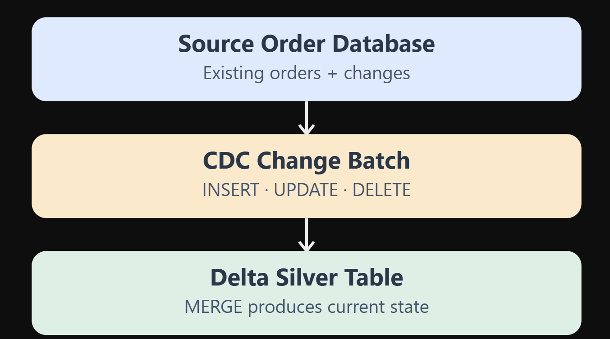

When should we use CDC?
Use CDC when the target data must reflect changes made in a source system without repeatedly copying the entire database.
Examples include customer profile updates in banking, changed order statuses in e-commerce, insurance policy amendments, and employee master-data synchronization.

Why use CDC?
Suppose a company's operational database contains 10 million orders. Only 5,000 orders change during a day.
A full load would read the entire 10-million-row dataset. CDC allows processing the relevant changes, potentially reducing data movement, processing duration and cost.

Architecture

1.2 Hands-on exercise
Problem statement: The source system sends three changes: order 101 is updated, order 106 is inserted, and order 105 is deleted.

Step 1 – Create the target Delta table
Run in a SQL cell:
-- Create the existing order table.
-- CREATE OR REPLACE is used only to reset this training lab.

Use catalog your_catalog;

CREATE OR REPLACE TABLE silver.orders_cdc (
order_id INT,
customer_id STRING,
amount DOUBLE,
status STRING,
updated_at TIMESTAMP
)
USING DELTA;

-- Insert the initial five source records.

INSERT INTO silver.orders_cdc VALUES
(101, 'C01', 1000, 'PENDING', '2026-10-16 09:00:00'),
(102, 'C02', 2000, 'COMPLETED', '2026-10-16 09:05:00'),
(103, 'C03', 1500, 'PENDING', '2026-10-16 09:10:00'),
(104, 'C04', 3000, 'COMPLETED', '2026-10-16 09:15:00'),
(105, 'C05', 500, 'PENDING', '2026-10-16 09:20:00');

-- View the initial dataset.
SELECT * FROM your_catalog.silver.orders_cdc
ORDER BY order_id;

Step 2 – Create a CDC change batch
-- This table simulates a change feed arriving from an
-- operational database such as Azure SQL Database.

CREATE OR REPLACE TABLE your_catalog.bronze.orders_cdc_events (
order_id INT,
customer_id STRING,
amount DOUBLE,
status STRING,
updated_at TIMESTAMP,
operation STRING
)
USING DELTA;

INSERT INTO your_catalog.bronze.orders_cdc_events VALUES

-- Existing order is modified.
(101, 'C01', 1200, 'COMPLETED',
'2026-10-16 10:00:00', 'UPDATE'),

-- New order is created.
(106, 'C06', 2500, 'PENDING',
'2026-10-16 10:05:00', 'INSERT'),

-- Existing order is deleted.
(105, 'C05', 500, 'PENDING',
'2026-10-16 10:10:00', 'DELETE');

Step 3 – Apply MERGE
-- MERGE compares source events with existing target orders.
-- The matching business key is order_id.

MERGE INTO your_catalog.silver.orders_cdc AS target
USING your_catalog.bronze.orders_cdc_events AS source

ON target.order_id = source.order_id

-- Remove orders marked DELETE.
WHEN MATCHED AND source.operation = 'DELETE'
THEN DELETE

-- Update orders that already exist.
WHEN MATCHED AND source.operation = 'UPDATE'
THEN UPDATE SET
target.amount = source.amount,
target.status = source.status,
target.updated_at = source.updated_at

-- Insert brand-new orders.
WHEN NOT MATCHED AND source.operation = 'INSERT'
THEN INSERT (
order_id,
customer_id,
amount,
status,
updated_at
)
VALUES (
source.order_id,
source.customer_id,
source.amount,
source.status,
source.updated_at
);

Explanation of MERGE
Clause | Purpose
MERGE INTO | Identifies the destination Delta table
USING | Identifies the incoming changes
ON | Matches records using the business key
WHEN MATCHED ... UPDATE | Changes existing records
WHEN MATCHED ... DELETE | Removes existing records
WHEN NOT MATCHED ... INSERT | Inserts new records

1.3 Expected output
order_id | customer_id | amount | status
101 | C01 | 1200 | COMPLETED
102 | C02 | 2000 | COMPLETED
103 | C03 | 1500 | PENDING
104 | C04 | 3000 | COMPLETED
106 | C06 | 2500 | PENDING

Validation SQL
-- Final number of orders must remain 5.
SELECT COUNT(*) AS total_orders
FROM your_catalog.silver.orders_cdc;

-- Order 101 must be updated.
SELECT * FROM your_catalog.silver.orders_cdc
WHERE order_id = 101;

-- Order 105 must not exist.
SELECT COUNT(*) AS deleted_order_remaining
FROM your_catalog.silver.orders_cdc
WHERE order_id = 105;

-- Order 106 must be present.
SELECT * FROM your_catalog.silver.orders_cdc
WHERE order_id = 106;
Expected: 5 total records, order 101 updated to ₹1,200, order 105 absent, and order 106 present.
Production consideration: This example assumes one correctly ordered event per order. Real CDC feeds can contain repeated or out-of-order updates. Production solutions should use source sequence numbers, event IDs, deterministic deduplication and stale-event protection.

Lab 2 – Delta Change Data Feed (CDF)

2.1 What is CDF?
Change Data Feed exposes the row-level changes made to a supported Delta table so downstream consumers can process inserts, updates and deletes.
A useful distinction:
CDC is the change-capture and synchronization pattern; CDF is a table feature/API for reading changes from Delta tables.
Azure Databricks now documents both automatic CDF for supported newer runtimes/tables and legacy CDF enabled through the delta.enableChangeDataFeed property. This lab uses the legacy property for broad training compatibility.
Microsoft Learn

When and why use CDF?
Suppose the Silver orders table is updated throughout the day, while a downstream reporting system needs only those changed rows.
Without CDF, the reporting process may need to scan the whole table or compare snapshots. With CDF, it can consume the changes between table versions.

2.2 Hands-on exercise

Step 1 – Create a CDF-enabled table
-- Enable CDF from the beginning of this new Delta table.

CREATE OR REPLACE TABLE your_catalog.silver.orders_cdf (
order_id INT,
customer_id STRING,
amount DOUBLE,
status STRING
)
USING DELTA
TBLPROPERTIES (
delta.enableChangeDataFeed = true
);

-- Insert baseline records.
INSERT INTO your_catalog.silver.orders_cdf VALUES
(101, 'C01', 1000, 'PENDING'),
(102, 'C02', 2000, 'COMPLETED'),
(103, 'C03', 1500, 'PENDING');

Step 2 – Update an order
-- The customer changes an order amount.
UPDATE your_catalog.silver.orders_cdf
SET amount = 2200
WHERE order_id = 102;

Step 3 – Delete an order
-- Order 103 is removed.
DELETE FROM your_catalog.silver.orders_cdf
WHERE order_id = 103;

Step 4 – Add a new order
INSERT INTO your_catalog.silver.orders_cdf VALUES
(104, 'C04', 3500, 'PENDING');

Step 5 – Inspect table history
-- Shows the exact Delta versions generated by operations.
DESCRIBE HISTORY your_catalog.silver.orders_cdf;

Step 6 – Read the Change Data Feed
For a freshly created table, this example normally produces the baseline insert as version 1, followed by the update, delete and insert in versions 2–4.
-- Read the changes starting from version 2.
-- Check DESCRIBE HISTORY before selecting your start version.

SELECT
order_id,
amount,
status,
_change_type,
_commit_version,
_commit_timestamp
FROM table_changes(
'your_catalog.silver.orders_cdf',
2
)
ORDER BY _commit_version, order_id, _change_type;

2.3 Expected CDF result
order_id | amount | _change_type
102 | 2000 | update_preimage
102 | 2200 | update_postimage
103 | 1500 | delete
104 | 3500 | insert

Understanding change types
update_preimage contains the original row before the UPDATE. update_postimage contains the new row. delete represents a removed row, while insert represents a new row.
This is useful when synchronizing downstream tables, maintaining change history or calculating the impact of transactions.

Validation
SELECT
_change_type,
COUNT(*) AS changes
FROM table_changes(
'your_catalog.silver.orders_cdf',
2
)
GROUP BY _change_type;
Expected: one record for each of the four change types shown above.
Important: CDF history is subject to retention. It should not be treated as a permanent audit archive without an explicit retention or archival design.
Microsoft Learn

Lab 3 – Incremental Load using a High-Water Mark

3.1 What is incremental loading?
Incremental loading processes only records that have been added or changed since the previous successful execution.
A high-water mark stores the greatest successfully processed source position, such as an increasing transaction ID, source sequence number or timestamp.

When to use it
Use high-water-mark ingestion for append-only source data, such as newly generated transaction IDs, event IDs or billing records.
For mutable tables where earlier records can be updated or deleted, a simple MAX(order_id) strategy is insufficient. Use a reliable modification timestamp or CDC.

3.2 Hands-on exercise

Step 1 – Create source and target tables
-- Source system containing orders.
CREATE OR REPLACE TABLE your_catalog.bronze.orders_incremental_source (
order_id INT,
amount DOUBLE,
status STRING
) USING DELTA;

INSERT INTO your_catalog.bronze.orders_incremental_source VALUES
(101, 1000, 'PENDING'),
(102, 2000, 'COMPLETED'),
(103, 1500, 'PENDING'),
(104, 3000, 'COMPLETED'),
(105, 500, 'PENDING');

-- Destination containing previously processed records.
CREATE OR REPLACE TABLE your_catalog.silver.orders_incremental (
order_id INT,
amount DOUBLE,
status STRING
) USING DELTA;

INSERT INTO your_catalog.silver.orders_incremental VALUES
(101, 1000, 'PENDING'),
(102, 2000, 'COMPLETED'),
(103, 1500, 'PENDING');

Step 2 – Identify the high-water mark
SELECT MAX(order_id) AS last_processed_order
FROM your_catalog.silver.orders_incremental;
Expected: 103

Step 3 – Perform incremental ingestion
-- Insert only records with an order_id above the stored maximum.
-- For this lab, IDs are strictly increasing and append-only.

INSERT INTO your_catalog.silver.orders_incremental
SELECT s.order_id, s.amount, s.status
FROM your_catalog.bronze.orders_incremental_source s
WHERE s.order_id > (
SELECT COALESCE(MAX(order_id), 0)
FROM your_catalog.silver.orders_incremental
);

Step 4 – Validate
SELECT *
FROM your_catalog.silver.orders_incremental
ORDER BY order_id;
Expected: Five orders, IDs 101–105.

Step 5 – Simulate the next day's arrivals
INSERT INTO your_catalog.bronze.orders_incremental_source VALUES
(106, 2500, 'PENDING'),
(107, 1800, 'COMPLETED');

Step 6 – Rerun incremental processing
INSERT INTO your_catalog.silver.orders_incremental
SELECT s.order_id, s.amount, s.status
FROM your_catalog.bronze.orders_incremental_source s
WHERE s.order_id > (
SELECT COALESCE(MAX(order_id), 0)
FROM your_catalog.silver.orders_incremental
);

Final validation
SELECT
COUNT(*) AS total_records,
MIN(order_id) AS first_order,
MAX(order_id) AS last_order
FROM your_catalog.silver.orders_incremental;
Expected:
total_records | first_order | last_order
7 | 101 | 107
Run Step 6 once more. The result should remain seven rows.
Real-world lesson: This pattern is simple and efficient for controlled append-only feeds. Production jobs should also persist the checkpoint transactionally and prevent overlapping runs so that simultaneous workers do not ingest duplicate ranges.

Lab 4 – Auto Loader for Incremental File Ingestion

4.1 What is Auto Loader?
Auto Loader is a Databricks file-ingestion mechanism that detects and processes files arriving in cloud object storage.
It uses the cloudFiles source with Structured Streaming and persists ingestion progress using checkpoints.
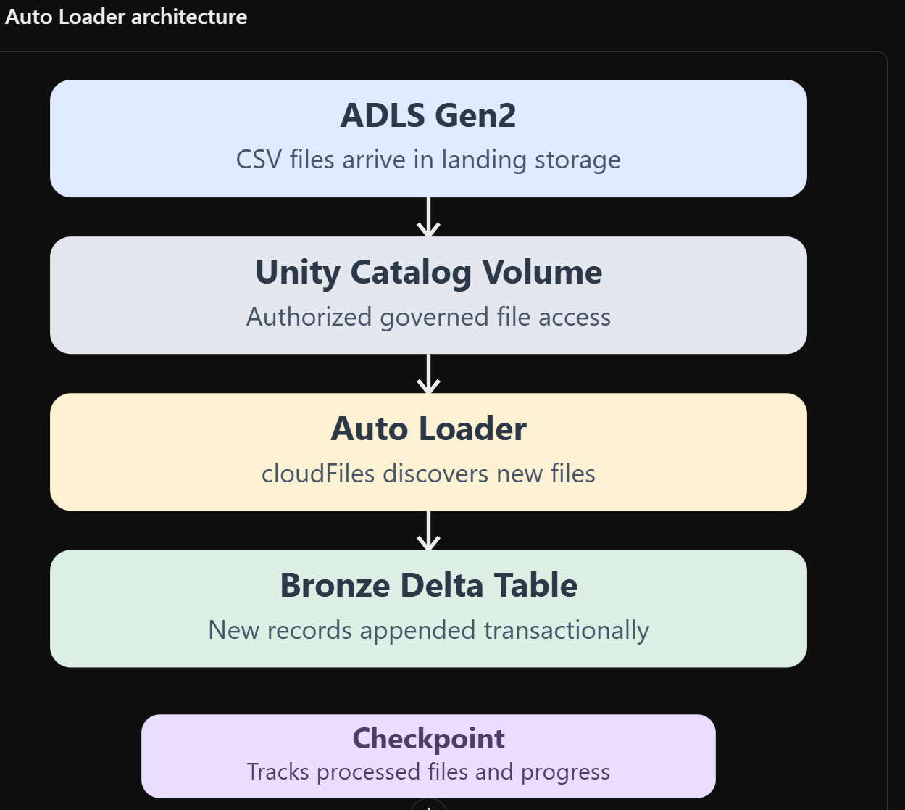

When should we use Auto Loader?
Consider a retail company receiving these files in Azure Data Lake Storage:
ADLS Gen2
└── retail-orders/
├── orders_day1.csv
├── orders_day2.csv
├── orders_day3.csv
└── orders_day4.csv
The company receives new files every few minutes or hours.
Use Auto Loader when the pipeline must automatically discover newly arriving files without repeatedly reprocessing historical files.

Why use it instead of spark.read.csv()?
spark.read.csv() | Auto Loader
Reads a bounded selection of files | Supports incremental discovery of new files
Requires external logic to track processed files | Maintains file-processing progress
Appropriate for one-time/batch reads | Appropriate for continuously arriving files
No streaming checkpoint by default | Uses checkpoint-based recovery
Simple initial implementation | Better suited to recurring file ingestion
Auto Loader supports directory listing and file event-based discovery strategies, depending on configuration and platform capabilities.
Microsoft Learn
+1

4.2 Auto Loader architecture

4.3 Prerequisites
The following lab assumes you have an existing Unity Catalog Volume.
For example:
/Volumes/your_catalog/bronze/retail_files/
You can use an existing external location and Volume from your Azure Databricks training environment. A new storage account or external location is not required.
The trainee needs access to create files in the Volume and create the destination Delta table.

4.4 Hands-on exercise
Run the following in a Python notebook, one cell at a time.

Step 1 – Configure storage paths
# Existing Unity Catalog Volume.# Change this path to your available Volume.volume_path = ( "/Volumes/your_catalog/bronze/retail_files")# Landing path contains only source CSV files.landing_path = f"{volume_path}/autoloader/input"# Metadata locations are outside the source input folder.checkpoint_path = f"{volume_path}/autoloader/checkpoint"schema_path = f"{volume_path}/autoloader/schema"# Prepare the landing folder.dbutils.fs.mkdirs(landing_path)print("Landing path:", landing_path)

Step 2 – Create the first CSV file
# Three new retail orders arrive from the source system.batch1 = """order_id,customer_id,amount,status201,C01,1000,COMPLETED202,C02,2000,PENDING203,C03,1500,COMPLETED"""dbutils.fs.put( f"{landing_path}/orders_batch1.csv", batch1, overwrite=True)# Confirm the file exists.display(dbutils.fs.ls(landing_path))

Step 3 – Define the source schema
from pyspark.sql.types import ( StructType, StructField, IntegerType, StringType, DoubleType)# Explicit schema avoids inferring data types for every batch.order_schema = StructType([ StructField("order_id", IntegerType()), StructField("customer_id", StringType()), StructField("amount", DoubleType()), StructField("status", StringType())])

Step 4 – Configure Auto Loader
# readStream creates an incremental streaming source.## cloudFiles enables Auto Loader.## cloudFiles.format = csv tells Auto Loader which source format to read.## header = true means the first row contains column names.## schemaLocation stores source schema tracking information.orders_stream = ( spark.readStream .format("cloudFiles") .option("cloudFiles.format", "csv") .option("header", "true") .option("cloudFiles.schemaLocation", schema_path) .schema(order_schema) .load(landing_path))

Step 5 – Execute ingestion
# Write discovered files into the Bronze Delta table.## availableNow=True processes the currently available backlog# and then terminates.## checkpointLocation tracks ingestion progress between executions.query = ( orders_stream.writeStream .format("delta") .option("checkpointLocation", checkpoint_path) .trigger(availableNow=True) .toTable("your_catalog.bronze.orders_autoloader"))# Wait for the current incremental run to finish.query.awaitTermination()

Step 6 – Validate the first batch
spark.sql("""SELECT *FROM your_catalog.bronze.orders_autoloaderORDER BY order_id""").show()
Expected: Three orders, 201–203.

Step 7 – Create a second CSV file
# A new file arrives after the previous ingestion run.batch2 = """order_id,customer_id,amount,status204,C04,3000,COMPLETED205,C05,2500,PENDING"""dbutils.fs.put( f"{landing_path}/orders_batch2.csv", batch2, overwrite=True)

Step 8 – Run Auto Loader again
# Reuse the same source definition and checkpoint.## Auto Loader tracks which files have already been processed.# It discovers the new file without intentionally reprocessing# orders_batch1.csv.query2 = ( orders_stream.writeStream .format("delta") .option("checkpointLocation", checkpoint_path) .trigger(availableNow=True) .toTable("your_catalog.bronze.orders_autoloader"))query2.awaitTermination()

Step 9 – Validate final output
SELECT
COUNT(*) AS total_orders,
SUM(amount) AS total_amount
FROM your_catalog.bronze.orders_autoloader;
Expected output
Total orders

5
Total amount

10,000
The result assumes a fresh folder, checkpoint and target table with only the two example files.

Important production rules
- Use a unique checkpoint for each distinct ingestion stream.
- Never store a streaming checkpoint inside the source input folder.
- Do not delete checkpoints as a routine method of restarting ingestion.
- Reprocessing the same business records under different filenames can still create business duplicates; file-level progress tracking does not replace business-key deduplication.
- Use explicit schema definitions and handle unexpected schema changes.

Lab 5 – Lakeflow Spark Declarative Pipelines (SDP)

5.1 What is SDP?
Lakeflow Spark Declarative Pipelines (SDP) is a Databricks framework for defining and operating data pipelines using declarative Python or SQL.
Instead of manually writing all the orchestration logic, a developer defines the expected datasets and transformations, and Databricks manages the resulting pipeline graph, execution and monitoring.

Imperative vs. declarative programming
In a traditional PySpark program:
# Imperative processing:# The developer executes an explicit write operation.df = spark.table("source_orders")clean_df = df.filter("amount > 0")clean_df.write.mode("overwrite").saveAsTable("clean_orders")
In an SDP pipeline:
# Declarative processing:# The developer describes the dataset definition.# Pipeline orchestration executes it.from pyspark import pipelines as dp@dp.materialized_view(name="clean_orders")def clean_orders(): return spark.read.table("source_orders").filter("amount > 0")
The second example must run in an appropriately configured pipeline or supported standalone declarative environment, not as a conventional Spark batch write.

5.2 When and why use SDP?
Use SDP when building managed ETL pipelines with multiple dependencies, data quality requirements, incremental processing and monitoring.
For example:
- Bronze collects raw orders.
- Silver validates and cleans orders.
- Gold calculates daily revenue.
- Databricks determines the dependency order and maintains pipeline execution.
Databricks currently recommends explicit decorators such as @dp.materialized_view for materialized views and @dp.table for streaming tables.
Microsoft Learn
+2

5.3 Hands-on exercise – Bronze → Silver → Gold

Business requirement
Learnlytica Retail wants to process source orders using three declarative datasets.
One order has an invalid negative amount, and another has a missing customer ID. Only valid orders should appear in Silver and contribute to Gold revenue.

Step 1 – Create the source table
Run this in a regular Databricks SQL notebook, before creating the pipeline.
CREATE OR REPLACE TABLE your_catalog.bronze.orders_sdp_source (
order_id INT,
customer_id STRING,
amount DOUBLE,
status STRING
)
USING DELTA;

INSERT INTO your_catalog.bronze.orders_sdp_source VALUES
(301, 'C01', 1000, 'COMPLETED'),
(302, 'C02', 2000, 'COMPLETED'),
(303, 'C03', -500, 'COMPLETED'),
(304, NULL, 1500, 'PENDING'),
(305, 'C05', 3000, 'COMPLETED');

Step 2 – Create the pipeline notebook
Create a separate Python notebook named Retail_SDP_Pipeline.
The following code belongs in the Lakeflow pipeline source notebook.
# =========================================================# LEARNLYTICA - LAKEFLOW SPARK DECLARATIVE PIPELINES# BRONZE -> SILVER -> GOLD# =========================================================from pyspark import pipelines as dpfrom pyspark.sql import functions as F# ---------------------------------------------------------# BRONZE LAYER# ---------------------------------------------------------# Definition:# Preserve raw source records in a declaratively managed dataset.## @dp.materialized_view tells Databricks to maintain a# materialized result based on the specified batch query.## For this introductory lab, the source is an existing# Delta table. It is read as a batch source.@dp.materialized_view( name="retail_bronze", comment="Raw retail order records")def retail_bronze(): return spark.read.table( "your_catalog.bronze.orders_sdp_source" )# ---------------------------------------------------------# SILVER LAYER# ---------------------------------------------------------# Business rules:

Step 3 – Create and run the pipeline
In Azure Databricks, open Jobs & Pipelines and create a Lakeflow Declarative Pipeline. Add Retail_SDP_Pipeline as the pipeline source, select your_catalog as the destination catalog and gold as the destination schema, then run a pipeline update.
The resulting datasets are:
your_catalog.gold.retail_bronze
your_catalog.gold.retail_silver
your_catalog.gold.retail_gold
These are logical medallion names within the selected pipeline schema. They are not physically separated into three Unity Catalog schemas in this introductory example. For enterprise implementations, separate schemas or pipelines can be used.

Step 4 – Validate Silver
SELECT *
FROM your_catalog.gold.retail_silver
ORDER BY order_id;
Expected:
order_id | customer_id | amount | status
301 | C01 | 1000 | COMPLETED
302 | C02 | 2000 | COMPLETED
305 | C05 | 3000 | COMPLETED
Two invalid records have been dropped.

Step 5 – Validate Gold
SELECT *
FROM your_catalog.gold.retail_gold;
Expected:
status | total_orders | total_amount
COMPLETED | 3 | 6000
What trainees learn: They do not explicitly call .write.saveAsTable() for each pipeline output. Instead, they define datasets and dependencies, and Lakeflow executes the pipeline.
For this first lab, the pipeline uses materialized views to demonstrate declarative transformations. A later exercise can replace the Bronze definition with an Auto Loader-based streaming table.

Lab 6 – Delta Live Tables (DLT) and Data Quality Expectations

6.1 What is DLT?
Delta Live Tables (DLT) was the previous name for the Databricks declarative pipeline functionality now known as Lakeflow Spark Declarative Pipelines.
The legacy Python API used:
import dlt
The current recommended Databricks API uses:
from pyspark import pipelines as dp
Existing DLT pipelines remain supported, but new training and development should prioritize the dp API.
Microsoft Learn

6.2 What are data quality expectations?
Data quality expectations define rules that records must satisfy during pipeline processing.
For example, an online retailer should not accept an order with a negative transaction amount or a missing customer ID.
There are three common expectation behaviors:
Expectation | Behavior | Example use case
expect | Records a rule violation but retains the row | Observe incomplete optional customer information
expect_or_drop | Excludes records violating the rule | Prevent negative order amounts entering Silver
expect_or_fail | Fails the affected pipeline update on rule violation | Reject critical invalid financial transactions

6.3 Hands-on exercise – Legacy DLT
Business scenario: The finance department requires a cleansed order table. Invalid monetary transactions must be rejected before downstream reporting.
Reuse the five source records from Lab 5, where orders 303 and 304 are invalid.

Step 1 – Create a DLT pipeline notebook
Create a separate Python notebook named Retail_Legacy_DLT.
# ==========================================================# LEARNLYTICA - LEGACY DELTA LIVE TABLES PRACTICE# ==========================================================## This notebook demonstrates the older DLT API.# Execute it as a Lakeflow Declarative Pipeline source.## Business rules:# 1. Orders must have positive amounts.# 2. Customer IDs cannot be NULL.# 3. Invalid records must be dropped.import dltfrom pyspark.sql import functions as F# ----------------------------------------------------------# BRONZE DATASET# ----------------------------------------------------------## Read the existing source table.## The legacy @dlt.table decorator is used to define# the materialized pipeline dataset.@dlt.table( name="legacy_bronze_orders", comment="Raw retail orders")def legacy_bronze_orders(): return spark.read.table( "your_catalog.bronze.orders_sdp_source" )

Step 2 – Configure the pipeline
Create a separate Lakeflow Declarative Pipeline with Retail_Legacy_DLT as its source. Set the destination to your_catalog.gold, then start a pipeline update.
Do not add the Lab 5 SDP notebook to the same pipeline because both exercises are intended to be run and inspected independently.

Step 3 – Validate the outputs
-- Raw input should contain five records.
SELECT COUNT(*) AS bronze_count
FROM your_catalog.gold.legacy_bronze_orders;

-- Silver should contain three valid records.
SELECT COUNT(*) AS silver_count
FROM your_catalog.gold.legacy_silver_orders;

-- Business reporting output.
SELECT *
FROM your_catalog.gold.legacy_gold_orders;
Expected:
Validation | Expected
Bronze count | 5
Silver count | 3
Dropped invalid records | 2
Completed order revenue | ₹6,000

Step 4 – Inspect data quality metrics
Open the pipeline's monitoring interface and inspect the update and expectation details. Identify the expectations positive_amount and customer_required.
Both failed records should be rejected by the configured rules. Expectation statistics are useful for understanding data quality failures before the records reach business reporting.
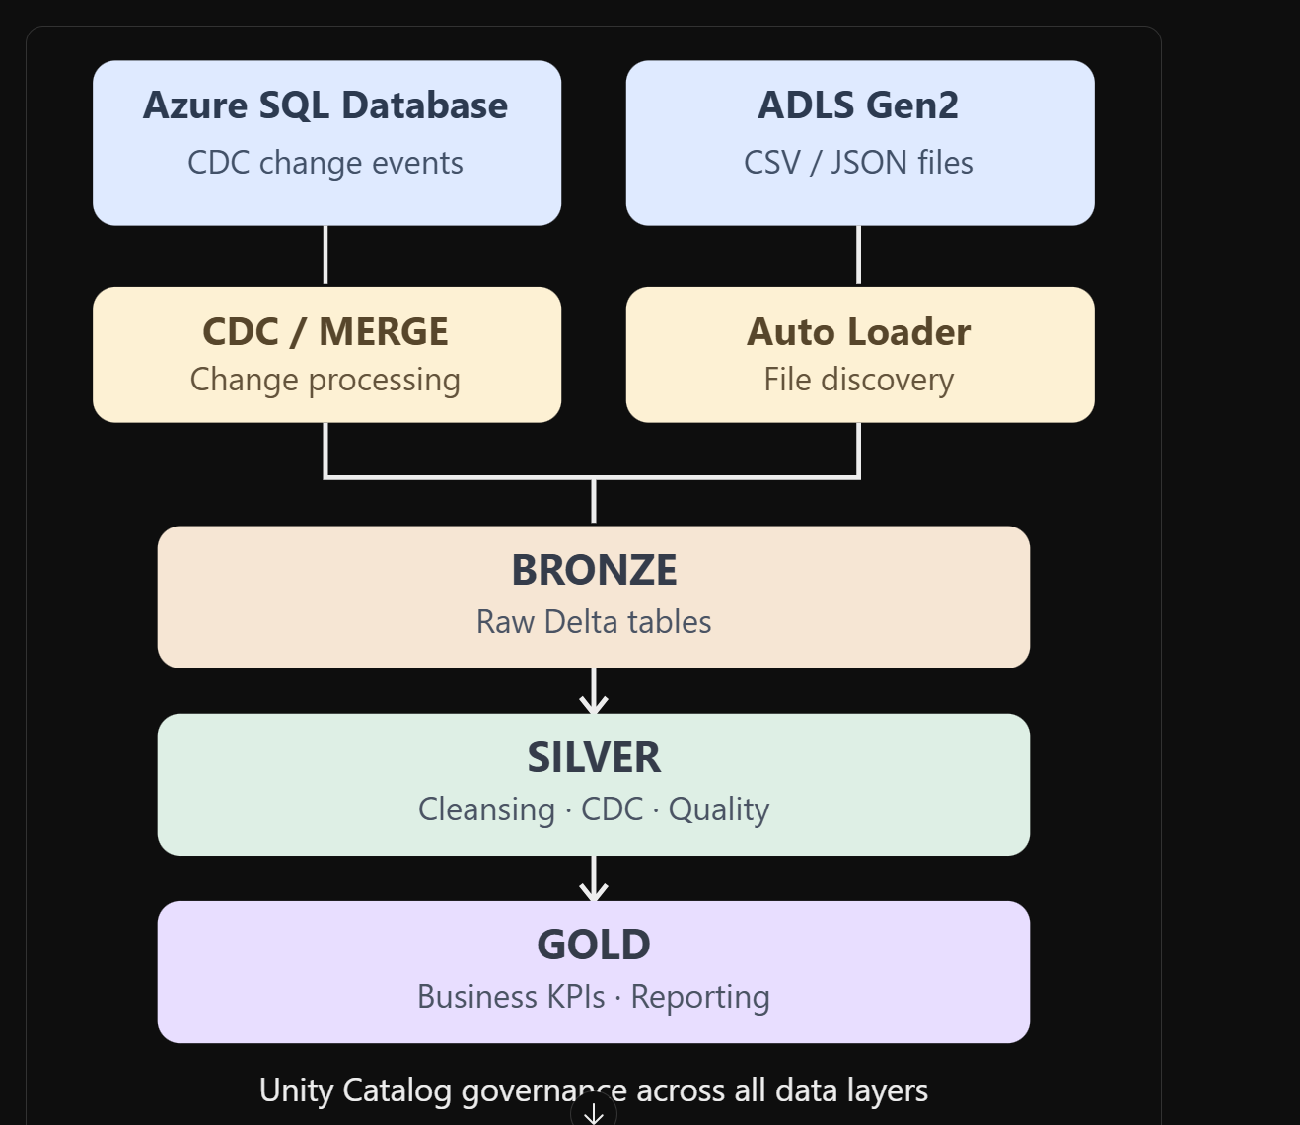

6.4 Modern SDP equivalent
The equivalent current syntax is:
# Modern Lakeflow Spark Declarative Pipelines syntax.# Use this in a pipeline source notebook.from pyspark import pipelines as dpfrom pyspark.sql import functions as F@dp.materialized_view( name="modern_silver_orders")@dp.expect_or_drop( "positive_amount", "amount > 0")@dp.expect_or_drop( "customer_required", "customer_id IS NOT NULL")def modern_silver_orders(): return ( spark.read.table( "your_catalog.bronze.orders_sdp_source" ) .withColumn( "status", F.upper(F.trim("status")) ) )
Both examples enforce the same business rules. The primary teaching difference is the legacy versus modern API and the explicit use of @dp.materialized_view in modern code.

Final comparison – When should trainees use each feature?
Feature | What it solves | Choose it when
CDC | Synchronizes source INSERT, UPDATE and DELETE events | Operational records can change
CDF | Exposes changes committed to a supported Delta table | Downstream consumers need changed rows
Incremental Load | Avoids reprocessing previously processed source data | Reliable new-record markers are available
Auto Loader | Discovers and ingests new storage files | CSV, JSON or Parquet files arrive repeatedly
Lakeflow SDP | Declaratively manages transformation pipelines | Multiple dependent datasets need orchestration, monitoring and quality rules
DLT (legacy API) | Earlier API for declarative pipelines | Maintaining or understanding existing DLT pipelines

Recommended enterprise architecture
Lakeflow SDP orchestrates the declarative transformations; Delta CDF can supply incremental changes to downstream consumers.

End-of-day practical assessment
After completing all six labs, give trainees one consolidated scenario:
Learnlytica Retail receives 500 new order records and 30 CDC events every hour. Some orders are updated, some are cancelled, and new order files arrive continuously in ADLS Gen2. The finance department requires accurate, validated revenue reports.
Ask trainees to identify which technology they would use for each requirement, then demonstrate:
- A CDC MERGE that updates, inserts and deletes records.
- A CDF query showing the resulting Delta changes.
- An incremental load that does not duplicate records on rerun.
- An Auto Loader stream that processes two successive CSV files.
- A Lakeflow pipeline that creates a cleansed Silver dataset.
- A data quality expectation that excludes invalid transactions.

Learnlytica – Azure Databricks CDC Hands-on Lab Using Employee Data
Topic: Change Data Capture (CDC) using Source Table, CDC Events Table and Target Delta Table Technology: Azure Databricks, Delta Lake, Spark SQL, MERGE Business scenario: Employee Master Data Synchronization Difficulty: Beginner to Intermediate Execution: Azure Databricks SQL notebook or SQL cells

1. Real-time business scenario
A company maintains employee information in an HR management system (HRMS). The data engineering team needs to synchronize employee records from HRMS to the Databricks Lakehouse for payroll, reporting and workforce analytics.
The HRMS contains employee IDs, names, departments, salaries and employment status.
During the day, the following changes occur:
- INSERT: A new employee, Kiran, joins the company.
- UPDATE: Ravi receives a salary increment.
- UPDATE: Priya moves from HR to Finance.
- DELETE: Arun's record is deleted from the operational employee table.
Instead of reloading the entire employee master table, the pipeline processes these changes using CDC events and Delta MERGE.

2. CDC architecture

Three tables used in this lab
Table | Purpose
employees_source | Current employee records in the simulated HRMS
employees_cdc_events | Captured INSERT, UPDATE and DELETE events
employees_target | Delta employee master synchronized from CDC
The key concept is that the source table contains the current state, while the CDC events table contains the changes that occurred. The target is synchronized by applying those events.

3. Complete step-by-step SQL lab
Use a Databricks SQL notebook. Each code block can be copied into a separate SQL cell.

Step 1 – Create the schema and three tables
-- =========================================================
-- LEARNLYTICA - EMPLOYEE CDC LAB
-- =========================================================
-- Use an existing Unity Catalog catalog.
-- This example assumes your_catalog already exists.

CREATE SCHEMA IF NOT EXISTS your_catalog.hr;

-- TABLE 1: Operational source employee table.
CREATE OR REPLACE TABLE your_catalog.hr.employees_source
(
emp_id INT,
emp_name STRING,
department STRING,
salary DOUBLE,
status STRING,
updated_at TIMESTAMP
)
USING DELTA;

-- TABLE 2: CDC events generated by the source system.
-- event_id provides a unique ordered event identifier.
-- operation indicates INSERT, UPDATE or DELETE.
CREATE OR REPLACE TABLE your_catalog.hr.employees_cdc_events
(
event_id INT,
emp_id INT,
emp_name STRING,
department STRING,
salary DOUBLE,
status STRING,
operation STRING,
event_time TIMESTAMP
)
USING DELTA;

-- TABLE 3: Target Delta table.
CREATE OR REPLACE TABLE your_catalog.hr.employees_target
(
emp_id INT,
emp_name STRING,
department STRING,
salary DOUBLE,
status STRING,
updated_at TIMESTAMP
)
USING DELTA;

Step 2 – Insert five employees into the source
-- Initial employee data in the HRMS source table.

INSERT INTO your_catalog.hr.employees_source VALUES
(101, 'Ravi', 'IT', 50000, 'ACTIVE', '2026-10-19 09:00:00'),
(102, 'Priya', 'HR', 45000, 'ACTIVE', '2026-10-19 09:00:00'),
(103, 'Arun', 'SALES', 40000, 'ACTIVE', '2026-10-19 09:00:00'),
(104, 'Meena', 'FINANCE', 60000, 'ACTIVE', '2026-10-19 09:00:00'),
(105, 'John', 'IT', 55000, 'ACTIVE', '2026-10-19 09:00:00');

-- View source records.
SELECT *
FROM your_catalog.hr.employees_source
ORDER BY emp_id;
Expected initial data
emp_id | emp_name | department | salary | status
101 | Ravi | IT | 50000 | ACTIVE
102 | Priya | HR | 45000 | ACTIVE
103 | Arun | SALES | 40000 | ACTIVE
104 | Meena | FINANCE | 60000 | ACTIVE
105 | John | IT | 55000 | ACTIVE

Step 3 – Perform the initial full load into the target
Why: Before processing CDC events, the target needs the initial state of the employee master.
-- Initial full load is performed once.
INSERT INTO your_catalog.hr.employees_target
SELECT *
FROM your_catalog.hr.employees_source;

-- Validate target.
SELECT *
FROM your_catalog.hr.employees_target
ORDER BY emp_id;
At this point:
Table | Record count
Source | 5
CDC Events | 0
Target | 5

Step 4 – Simulate changes in the HRMS source
Now four employee changes occur.
Event | emp_id | Employee | Change
UPDATE | 101 | Ravi | Salary ₹50,000 → ₹60,000
UPDATE | 102 | Priya | HR → FINANCE
INSERT | 106 | Kiran | New employee, IT, ₹48,000
DELETE | 103 | Arun | Employee record removed
First update the source table to represent the operational system's new state.
-- =========================================================
-- SOURCE SYSTEM CHANGES
-- =========================================================

-- 1. Ravi receives a salary increment.
UPDATE your_catalog.hr.employees_source
SET salary = 60000,
updated_at = TIMESTAMP '2026-10-19 10:00:00'
WHERE emp_id = 101;

-- 2. Priya is transferred from HR to FINANCE.
UPDATE your_catalog.hr.employees_source
SET department = 'FINANCE',
updated_at = TIMESTAMP '2026-10-19 10:05:00'
WHERE emp_id = 102;

-- 3. Kiran joins as a new employee.
INSERT INTO your_catalog.hr.employees_source VALUES
(106, 'Kiran', 'IT', 48000, 'ACTIVE',
TIMESTAMP '2026-10-19 10:10:00');

-- 4. Arun's record is deleted.
DELETE FROM your_catalog.hr.employees_source
WHERE emp_id = 103;

-- View the latest source state.
SELECT *
FROM your_catalog.hr.employees_source
ORDER BY emp_id;
Expected source state
emp_id | emp_name | department | salary
101 | Ravi | IT | 60000
102 | Priya | FINANCE | 45000
104 | Meena | FINANCE | 60000
105 | John | IT | 55000
106 | Kiran | IT | 48000
Notice that the target still contains the old employee records because the CDC pipeline has not yet executed.

Step 5 – Insert the captured changes into the CDC events table
In a real-world implementation, a source change capture service or event-based integration produces these events. For this beginner lab, we insert them manually to demonstrate CDC processing.
-- =========================================================
-- CDC EVENTS
-- =========================================================
-- event_id identifies the ordered change event.
-- event_time identifies the source event timestamp.
--
-- DELETE carries the employee business key.
-- Other values may be NULL because the row is being deleted.

INSERT INTO your_catalog.hr.employees_cdc_events VALUES

-- Event 1: Ravi salary increment.
(1, 101, 'Ravi', 'IT', 60000, 'ACTIVE',
'UPDATE', TIMESTAMP '2026-10-19 10:00:00'),

-- Event 2: Priya department transfer.
(2, 102, 'Priya', 'FINANCE', 45000, 'ACTIVE',
'UPDATE', TIMESTAMP '2026-10-19 10:05:00'),

-- Event 3: Kiran joins.
(3, 106, 'Kiran', 'IT', 48000, 'ACTIVE',
'INSERT', TIMESTAMP '2026-10-19 10:10:00'),

-- Event 4: Arun deleted from source.
(4, 103, NULL, NULL, NULL, NULL,
'DELETE', TIMESTAMP '2026-10-19 10:15:00');

-- View all CDC events.
SELECT *
FROM your_catalog.hr.employees_cdc_events
ORDER BY event_id;

CDC event interpretation
event_id | emp_id | operation | Meaning
1 | 101 | UPDATE | Update Ravi's salary
2 | 102 | UPDATE | Update Priya's department
3 | 106 | INSERT | Insert Kiran
4 | 103 | DELETE | Delete Arun
Why is the events table separate from the source? Because an operational source table displays the latest values but does not, by itself, tell you every change that happened. CDC events preserve the operations needed for incremental synchronization.

Step 6 – Check the target before MERGE
-- Target still contains its initial values.
SELECT *
FROM your_catalog.hr.employees_target
ORDER BY emp_id;
The target still has Ravi at ₹50,000, Priya in HR, Arun present, and no Kiran record.

Step 7 – Apply CDC using Delta MERGE
This is the most important step.
-- =========================================================
-- APPLY CDC EVENTS TO TARGET
-- =========================================================

MERGE INTO your_catalog.hr.employees_target AS tgt
USING your_catalog.hr.employees_cdc_events AS src

-- emp_id is the business key.
ON tgt.emp_id = src.emp_id

-- DELETE existing employee when a delete event arrives.
WHEN MATCHED AND src.operation = 'DELETE'
THEN DELETE

-- UPDATE existing employee with changed source values.
WHEN MATCHED AND src.operation = 'UPDATE'
THEN UPDATE SET
tgt.emp_name = src.emp_name,
tgt.department = src.department,
tgt.salary = src.salary,
tgt.status = src.status,
tgt.updated_at = src.event_time

-- INSERT employee if there is no matching target record.
WHEN NOT MATCHED AND src.operation = 'INSERT'
THEN INSERT (
emp_id,
emp_name,
department,
salary,
status,
updated_at
)
VALUES (
src.emp_id,
src.emp_name,
src.department,
src.salary,
src.status,
src.event_time
);

Explanation of MERGE clauses
SQL clause | Explanation
MERGE INTO ... AS tgt | Destination Delta employee table
USING ... AS src | Incoming CDC events
ON tgt.emp_id = src.emp_id | Matches employees using business ID
WHEN MATCHED ... DELETE | Deletes employee if event type is DELETE
WHEN MATCHED ... UPDATE | Updates employee attributes
WHEN NOT MATCHED ... INSERT | Inserts a new employee
For this lab, each employee has at most one CDC event. In a production feed, an employee may have multiple changes within a batch; these must be resolved using their correct source event order before MERGE.

Step 8 – Validate the target after MERGE
SELECT
emp_id,
emp_name,
department,
salary,
status
FROM your_catalog.hr.employees_target
ORDER BY emp_id;
Expected final target table
emp_id | emp_name | department | salary | status
101 | Ravi | IT | 60000 | ACTIVE
102 | Priya | FINANCE | 45000 | ACTIVE
104 | Meena | FINANCE | 60000 | ACTIVE
105 | John | IT | 55000 | ACTIVE
106 | Kiran | IT | 48000 | ACTIVE
Final reconciliation
Source employees

5
CDC events

4
Target employees

5

Step 9 – Execute SQL validation queries
-- Validation 1: Target row count must equal 5.
SELECT COUNT(*) AS total_employees
FROM your_catalog.hr.employees_target;

-- Validation 2: Ravi salary must be 60000.
SELECT emp_id, salary
FROM your_catalog.hr.employees_target
WHERE emp_id = 101;

-- Validation 3: Priya must be in FINANCE.
SELECT emp_id, department
FROM your_catalog.hr.employees_target
WHERE emp_id = 102;

-- Validation 4: New employee Kiran must exist.
SELECT *
FROM your_catalog.hr.employees_target
WHERE emp_id = 106;

-- Validation 5: Arun must not exist.
SELECT COUNT(*) AS deleted_employee_count
FROM your_catalog.hr.employees_target
WHERE emp_id = 103;

-- Validation 6: Compare source and target using EXCEPT.
-- This query must return zero records.
SELECT * FROM your_catalog.hr.employees_source
EXCEPT
SELECT * FROM your_catalog.hr.employees_target;

-- Validation 7: Check the reverse difference as well.
-- This query must also return zero records.
SELECT * FROM your_catalog.hr.employees_target
EXCEPT
SELECT * FROM your_catalog.hr.employees_source;
The two EXCEPT queries together verify that the source and target have the same distinct rows, including the employee attributes and timestamps. For this lab, emp_id values are unique.

Step 10 – Observe the Delta transaction history
-- Inspect all Delta operations performed on the target.
DESCRIBE HISTORY your_catalog.hr.employees_target;

-- Inspect target storage and format.
DESCRIBE DETAIL your_catalog.hr.employees_target;
Trainees should identify the initial load operation and the subsequent MERGE operation.

4. Additional practice: Employee CDC Scenario 2
After the first MERGE, introduce another CDC batch.
Employee | Change | Expected action
Meena (104) | Salary increases to 65,000 | UPDATE
John (105) | Department changes to SUPPORT | UPDATE
Divya (107) | Joins HR at 42,000 | INSERT
Trainee assignment: Update the source, append three new events with event IDs 5–7, then merge only the new events into the target.
A simple training query can filter the new batch:
MERGE INTO your_catalog.hr.employees_target AS tgt
USING (
SELECT *
FROM your_catalog.hr.employees_cdc_events
WHERE event_id BETWEEN 5 AND 7
) AS src
ON tgt.emp_id = src.emp_id

WHEN MATCHED AND src.operation = 'DELETE'
THEN DELETE

WHEN MATCHED AND src.operation = 'UPDATE'
THEN UPDATE SET
tgt.emp_name = src.emp_name,
tgt.department = src.department,
tgt.salary = src.salary,
tgt.status = src.status,
tgt.updated_at = src.event_time

WHEN NOT MATCHED AND src.operation = 'INSERT'
THEN INSERT (
emp_id, emp_name, department,
salary, status, updated_at
)
VALUES (
src.emp_id, src.emp_name, src.department,
src.salary, src.status, src.event_time
);
In production, replace the hardcoded event ID range with a durable, successfully committed processing checkpoint.

5. CDC interview and troubleshooting questions
1. Why is the CDC events table needed when the source table already contains the latest employee data?
2. What happens if the same employee has two UPDATE events in one MERGE source batch?
3. Does MERGE automatically prevent stale CDC updates?
4. Can CDC maintain deleted employee history?

